Test 2: num_plants = 167 target*size = (299,299) batchsize = 32 epochs = 100 Model: "sequential" __* Layer (type) Output Shape Param #  
================================================================= inception_resnet*v2 (Model) (None, None, None, 1536) 54336736  
__* global_average*pooling2d (Gl (None, 1536) 0  
__* dense (Dense) (None, 2048) 3147776  
_ dense*1 (Dense) (None, 1024) 2098176  
__* dense*2 (Dense) (None, 512) 524800  
__* dense_3 (Dense) (None, 167) 85671  
================================================================= Total params: 60,193,159 Trainable params: 60,132,615 Non-trainable params: 60,544 72/72 [==============================] - 126s 2s/step - loss: 1.2155 - accuracy: 0.6852 test acc: 0.6851852

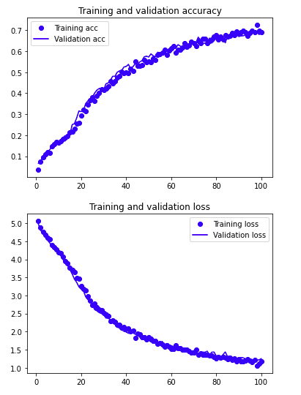

Conclusion: Accuracy greatly increased with larger representation space. Also increased batch size. Going to test an even larger dense layer.